# Overview

The red arm is the front/nose of the drone. Added the Styrofoam to save the plastic legs and to make the landing smoother. Also used for mounting the Ultrasonic and IR-lock sensors. Attached to the drone with a rope so it doesn’t fall of.

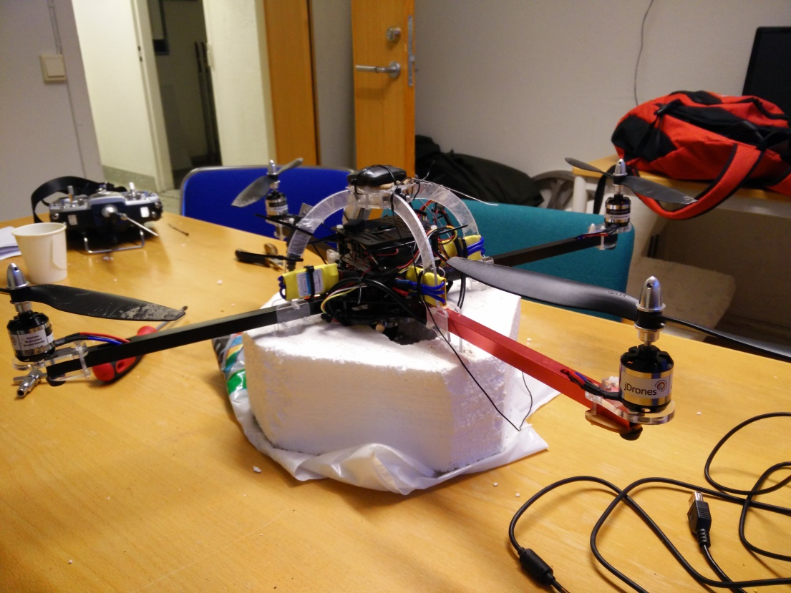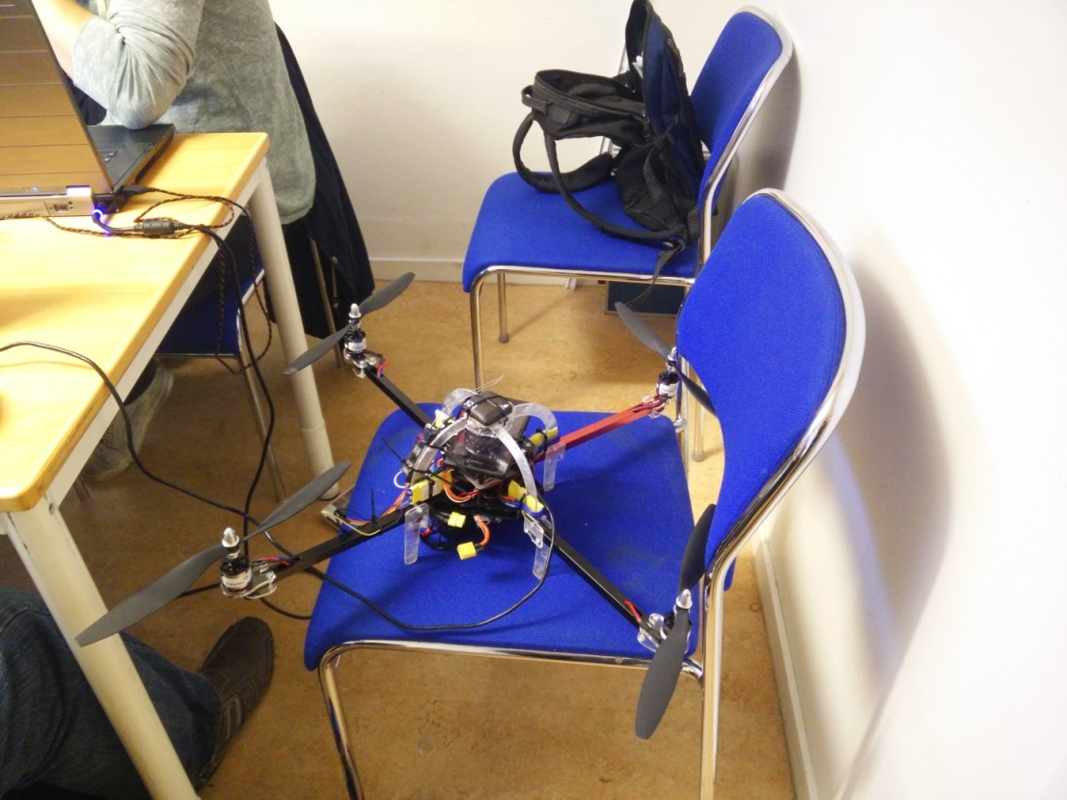

## Pixhawk wiring:

<https://pixhawk.org/modules/pixhawk>

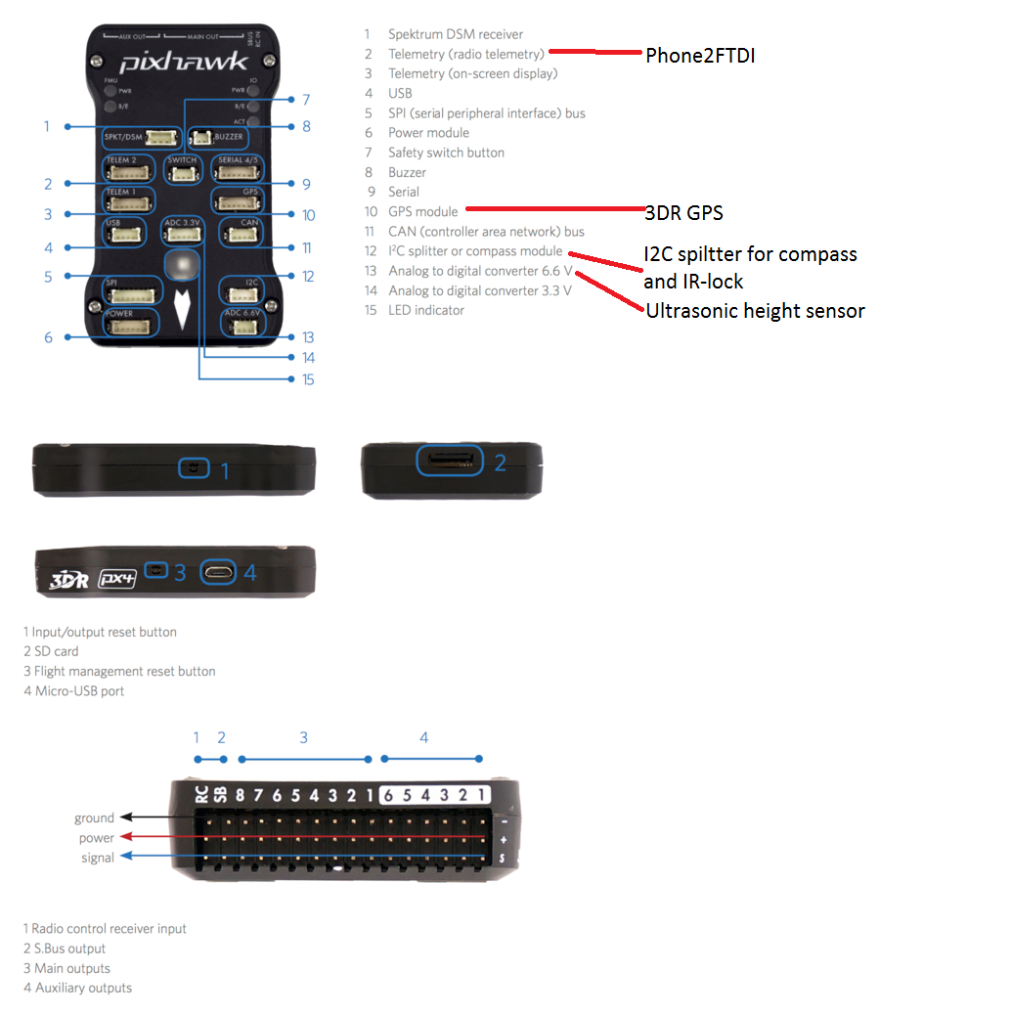

LED indicator color:

Blue = waiting on failsafes, probably good GPS lock

Green = Ready to fly

# Overview and battery connector

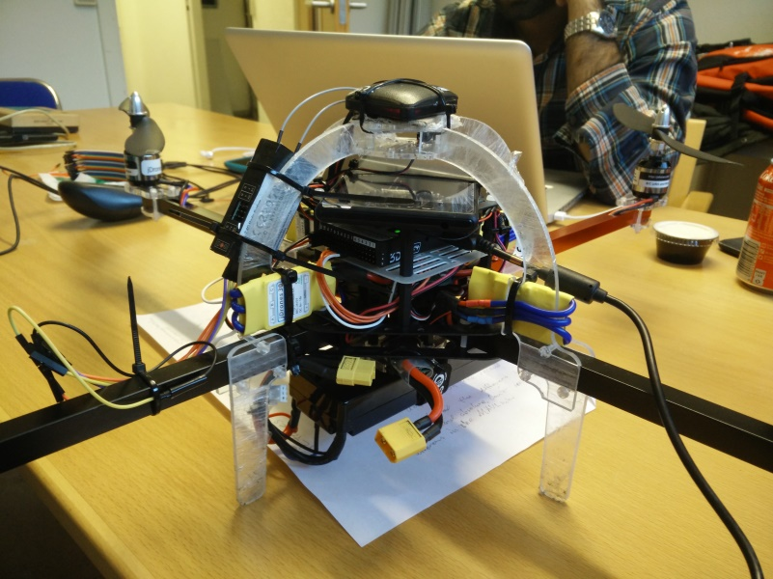Only way to completely shut down the connector is to remove the battery connector.

From bottom:

* Battery
* Battery holder
* Main chassis plate
  + Power measurement circuit board
  + Speaker
* Power distribution board
* First shelf
  + 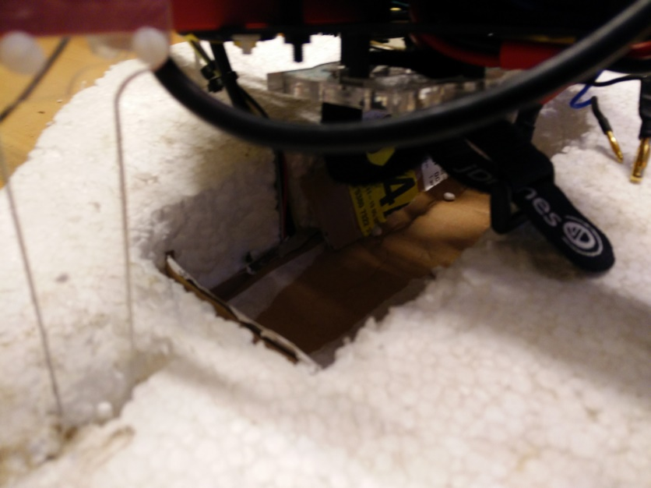Pixhawk

Battery compartment

* Second shelf
  + Phone
* Rollhoop
  + Safety switch
  + Radio transmitter
  + GPS+Compass

# Output and Radio connector

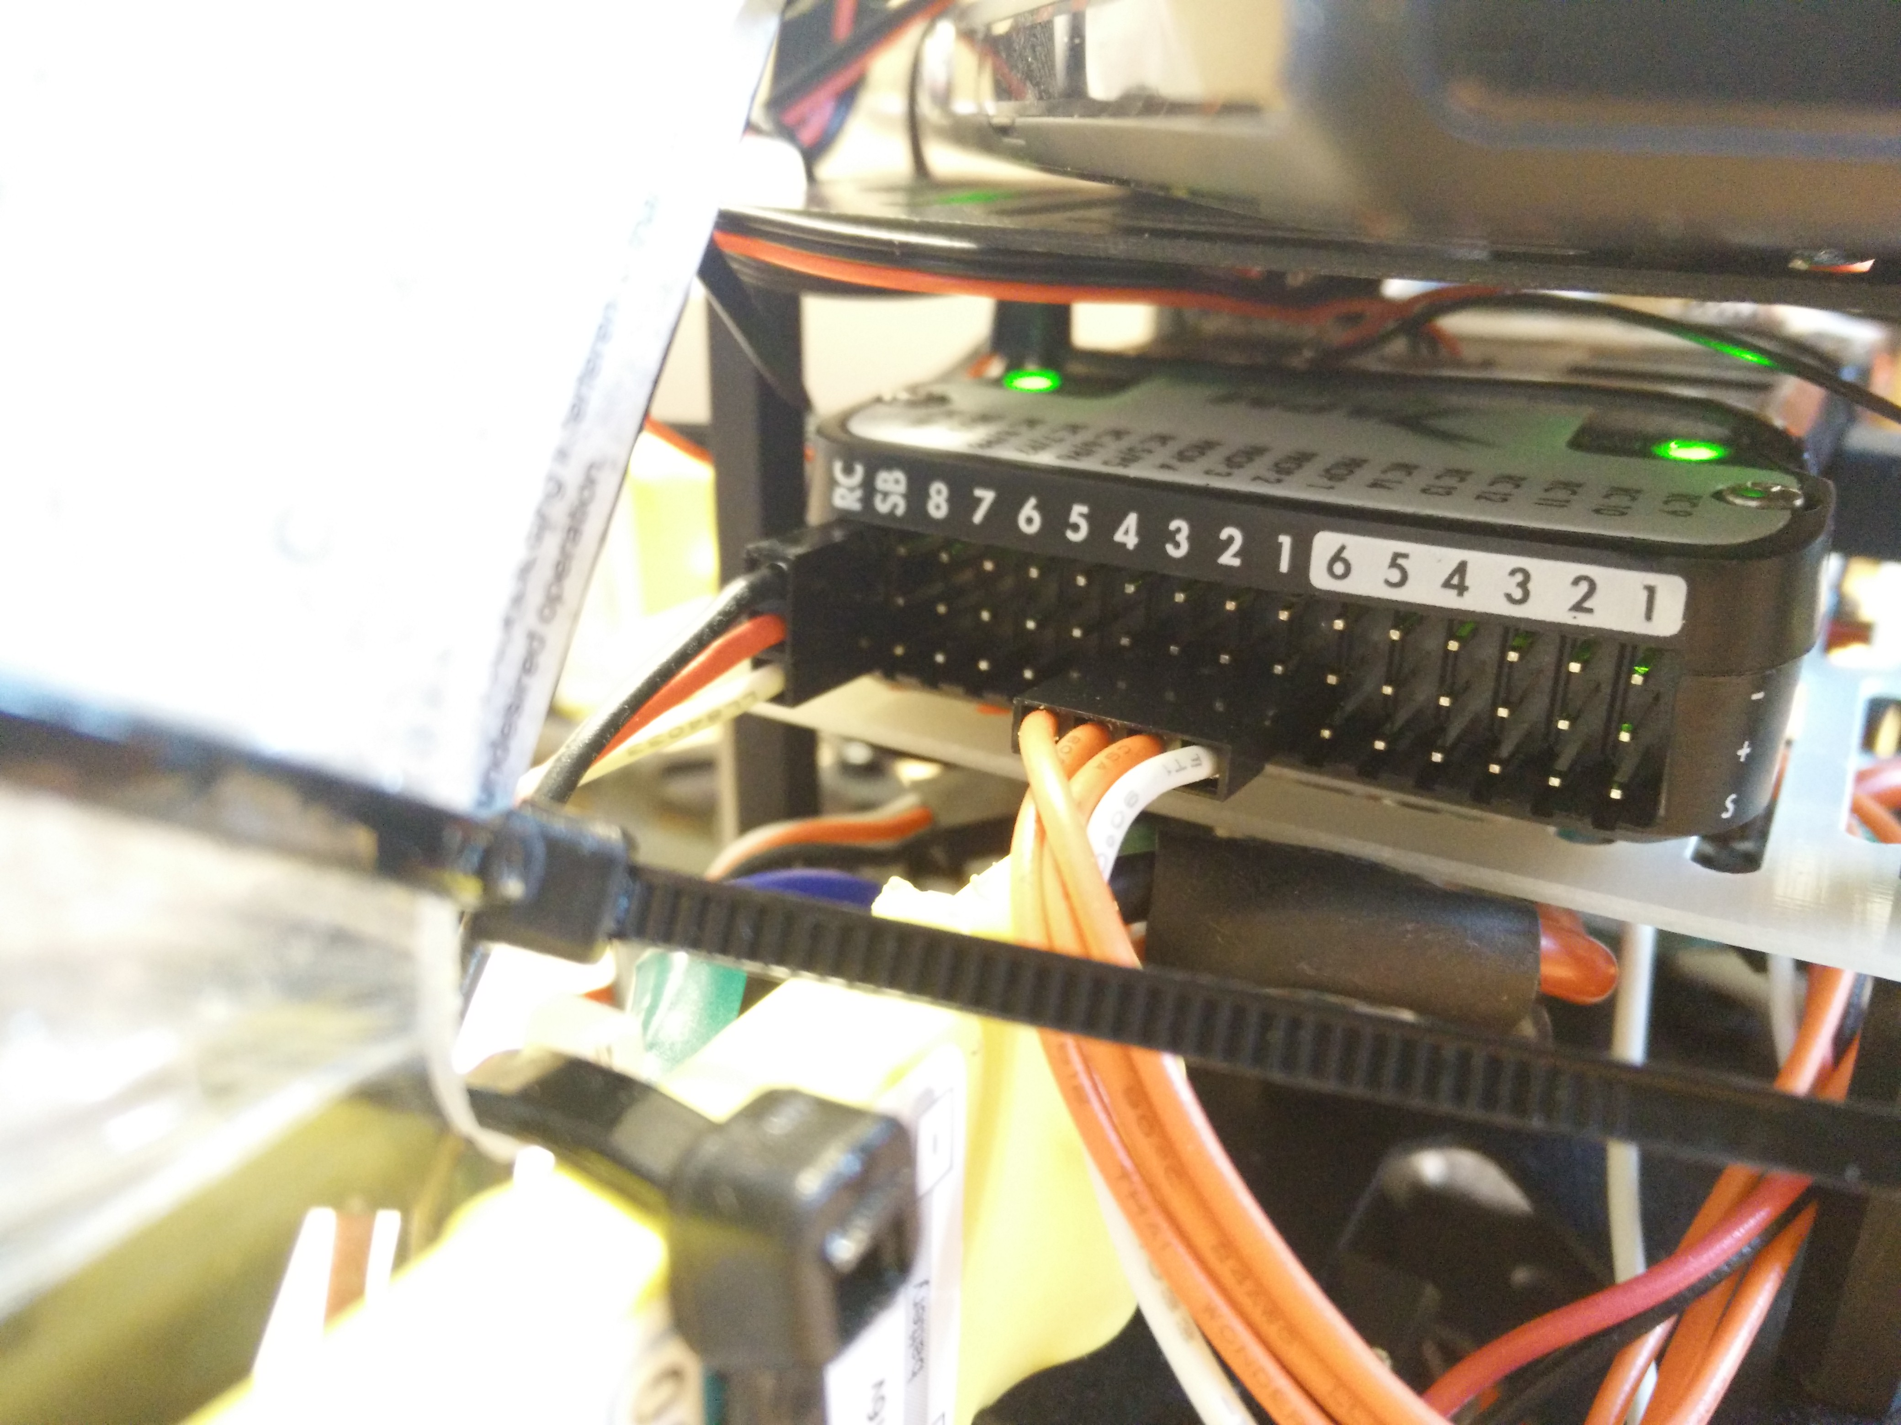

From bottom up:

* Signal
* Positive supply out
* Ground

From left to right:

Radio Connection

* PPM Radio Transmitter
* SB: NC

Main ESC output PWM

* 8
* 7
* 6

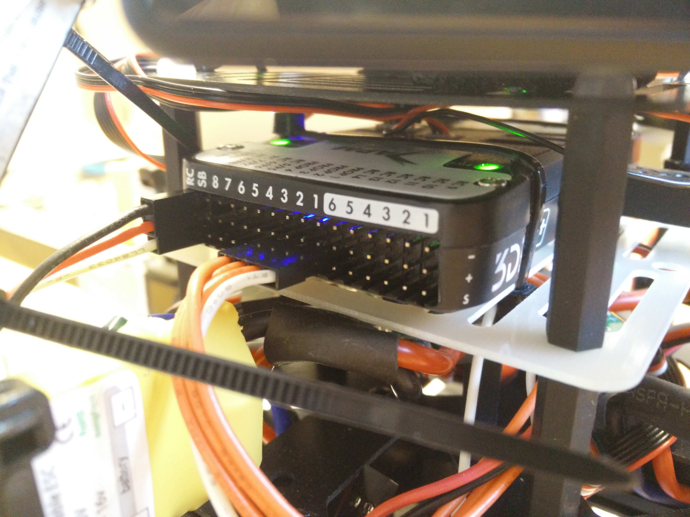

* 5
* 4: ESC 4
* 3: ESC 3
* 2: ESC 2
* 1: ESC 1

AUX output PWM

* 6
* 5
* 4
* 3
* 2
* 1

# GPS and compass

It’s important to place the sensor with the Arrow pointing in the same direction as the quadcopter nose.

Red light means that the unit has power and blinking blue means that is has a GPS lock.

GPS Left to right

* VCC
* RX
* TX
* NC
* NC
* GND

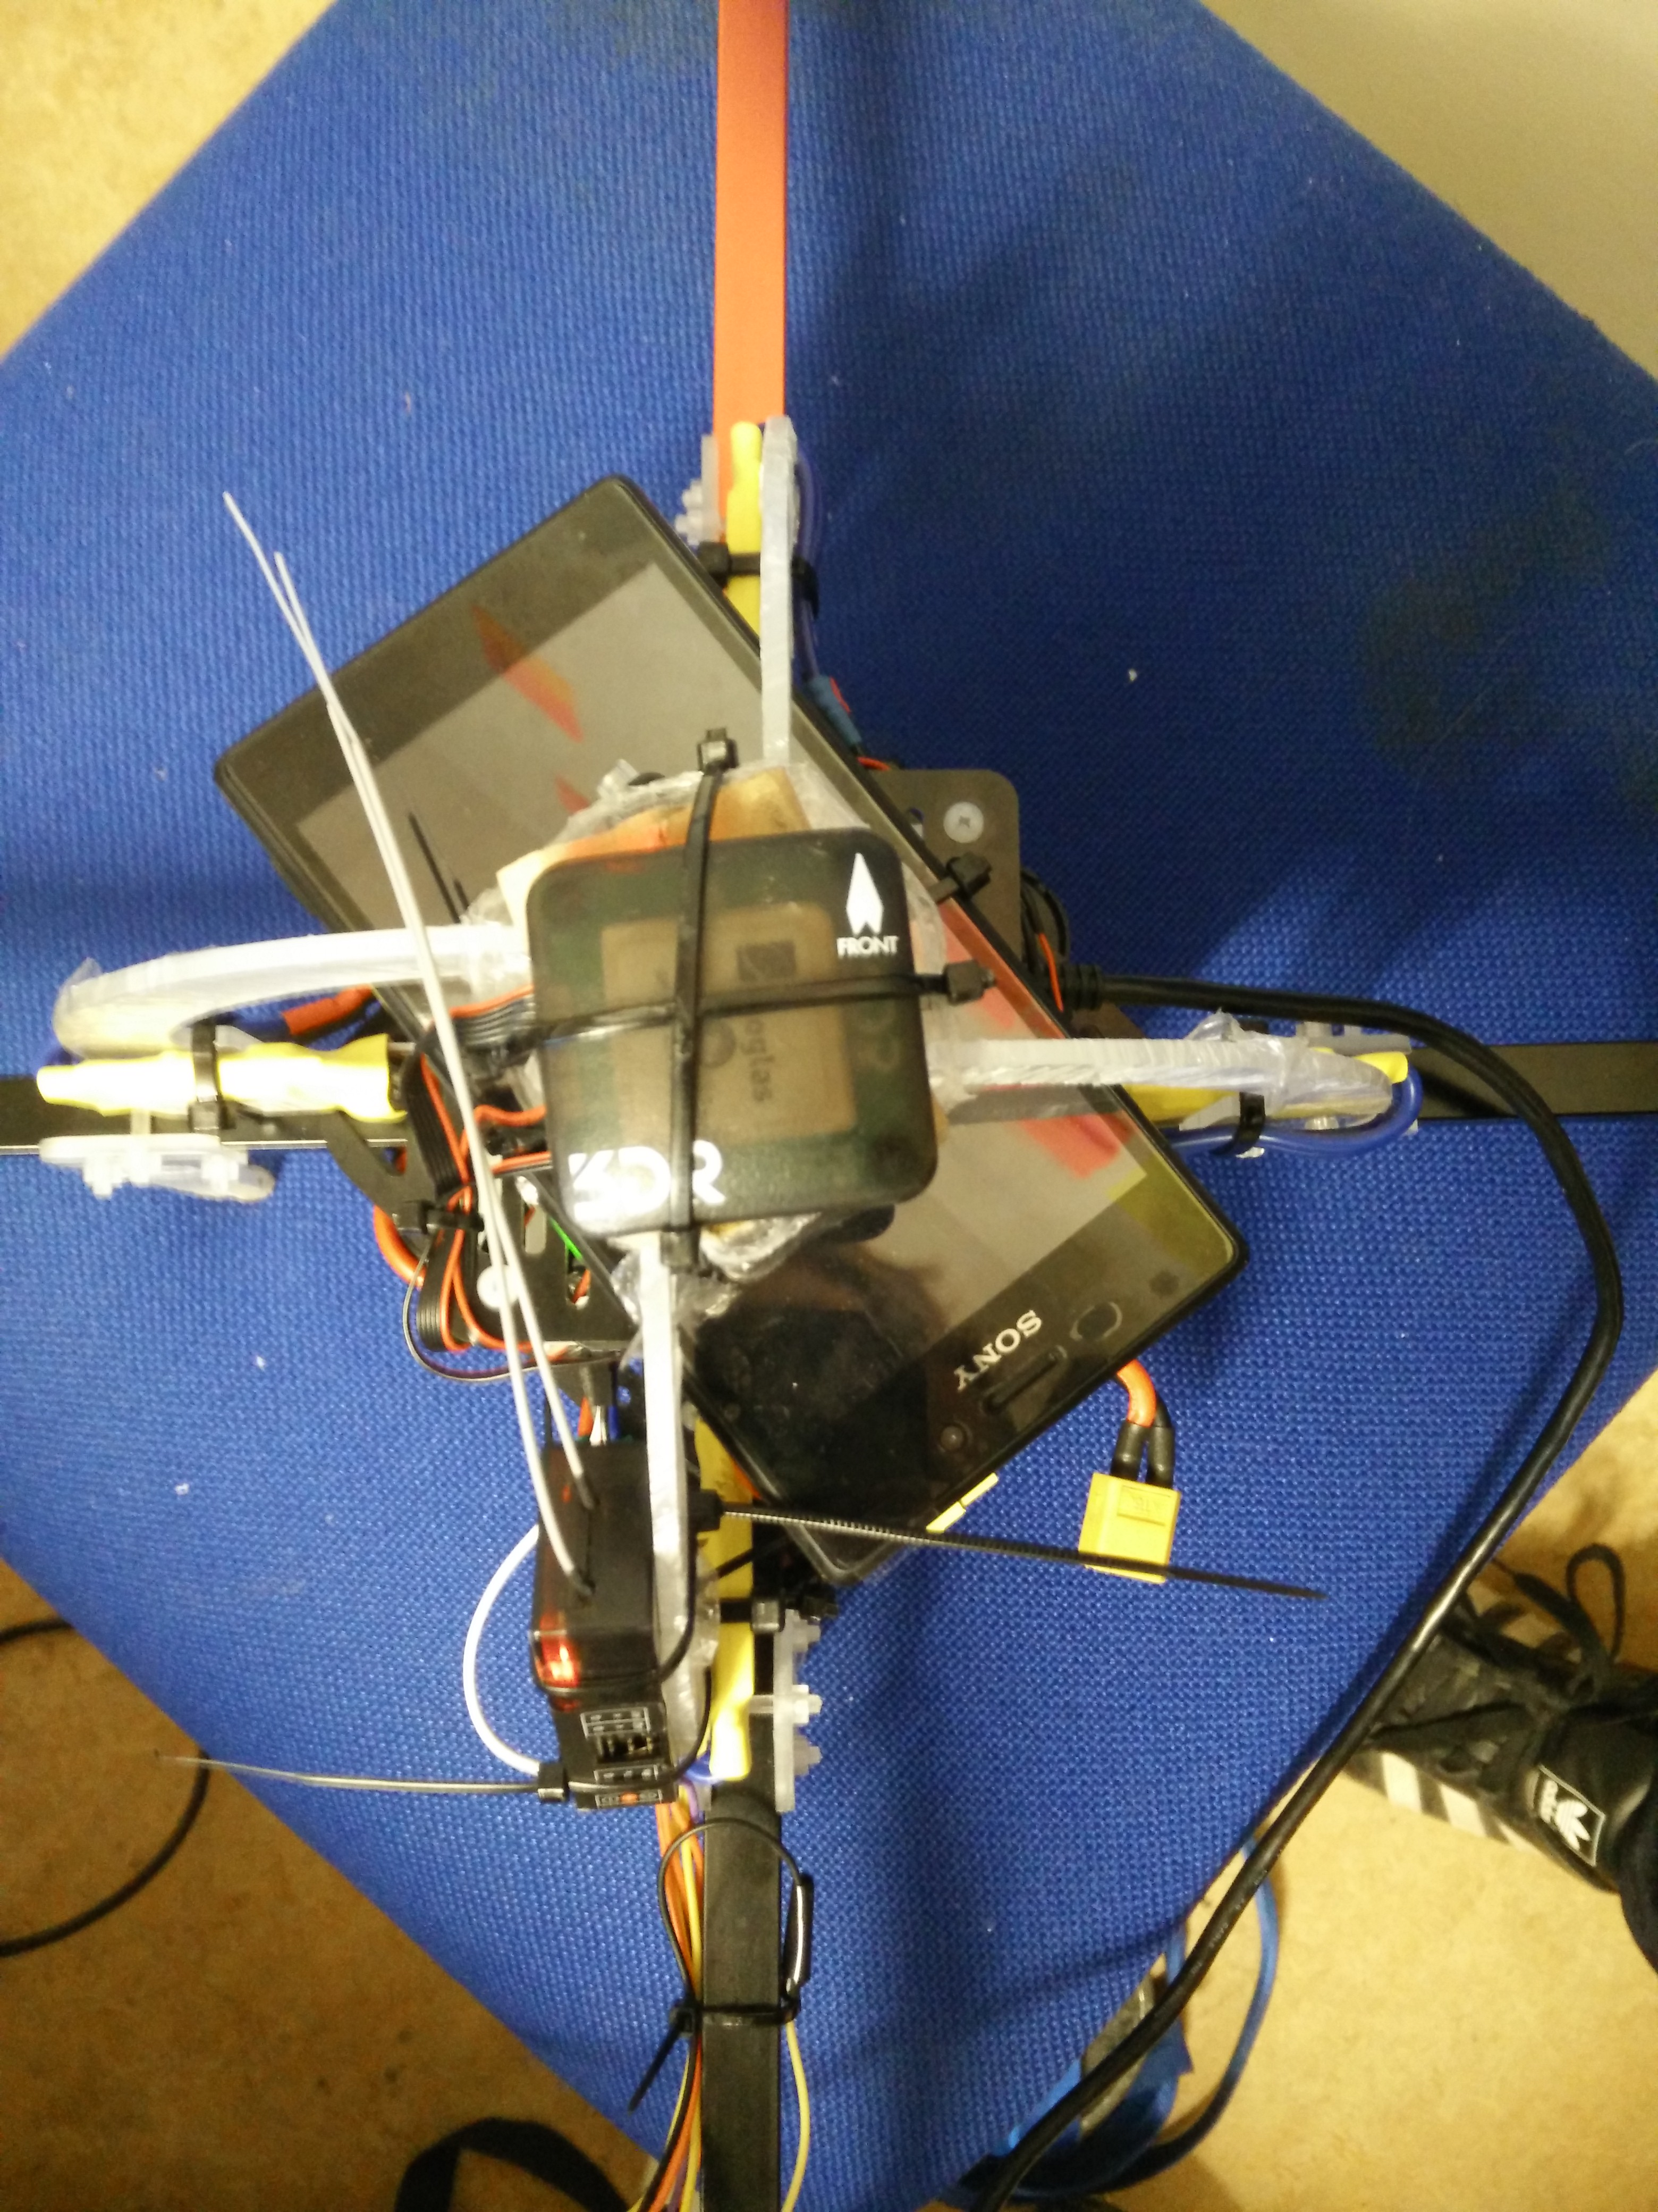

Compass

* 3.3V
* SCL
* SDA
* GND

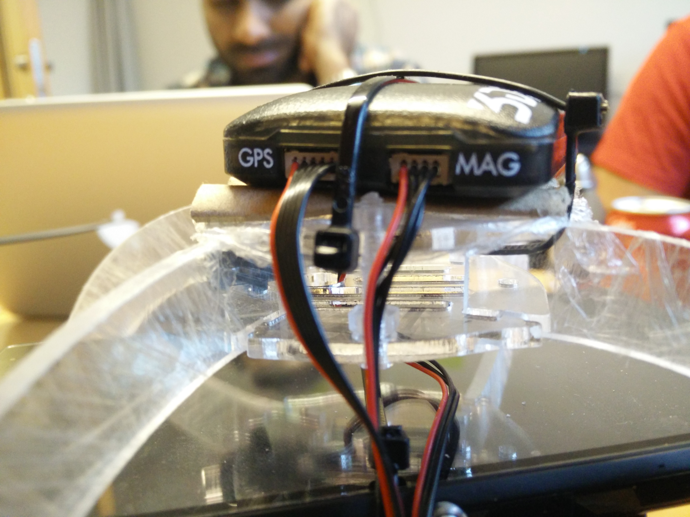

# Radio Transmitter

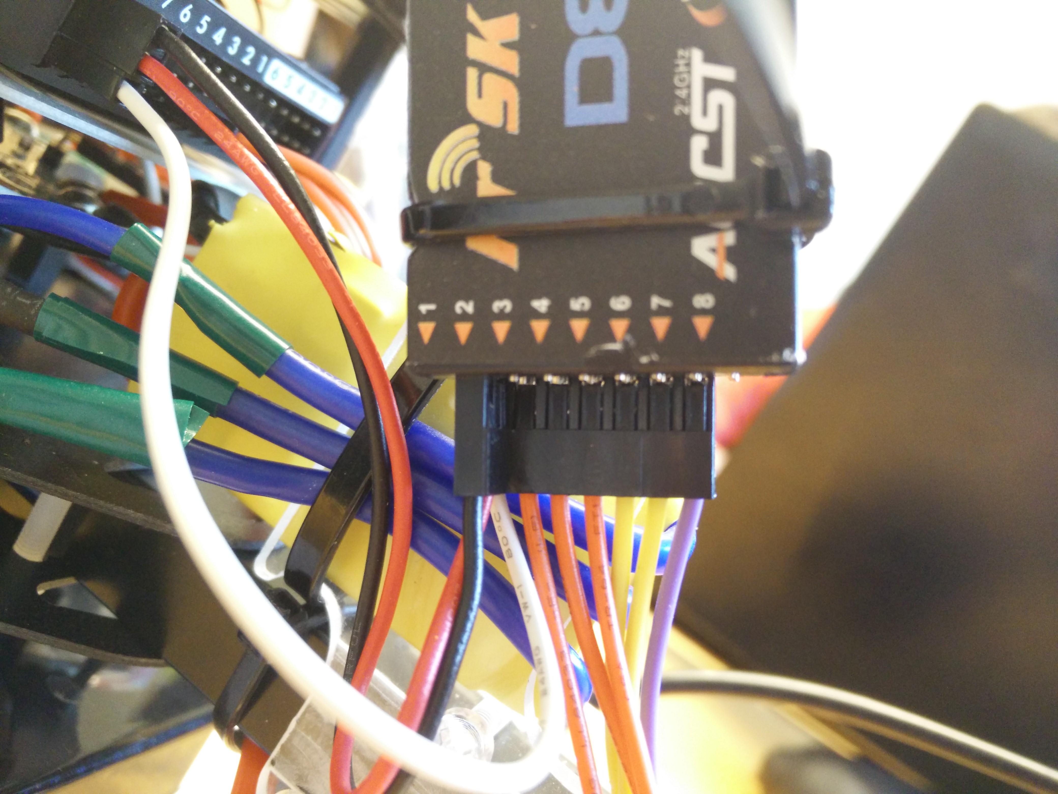

The Transmitter has been reflashed to another firmware that supports CPPM output.

http://www.rcgroups.com/forums/showthread.php?t=1866014#post24625982

From bottom up:

* Signal
* Positive supply in
* Ground

From left to right:

Output

* 1: CPPM Radio Transmitter
* 2: NC
* 3: Jumper to 4 for CPPM mode
* 4: Jumper to 3 for CPPM
* 5: NC
* 6: NC

Side

* Channel

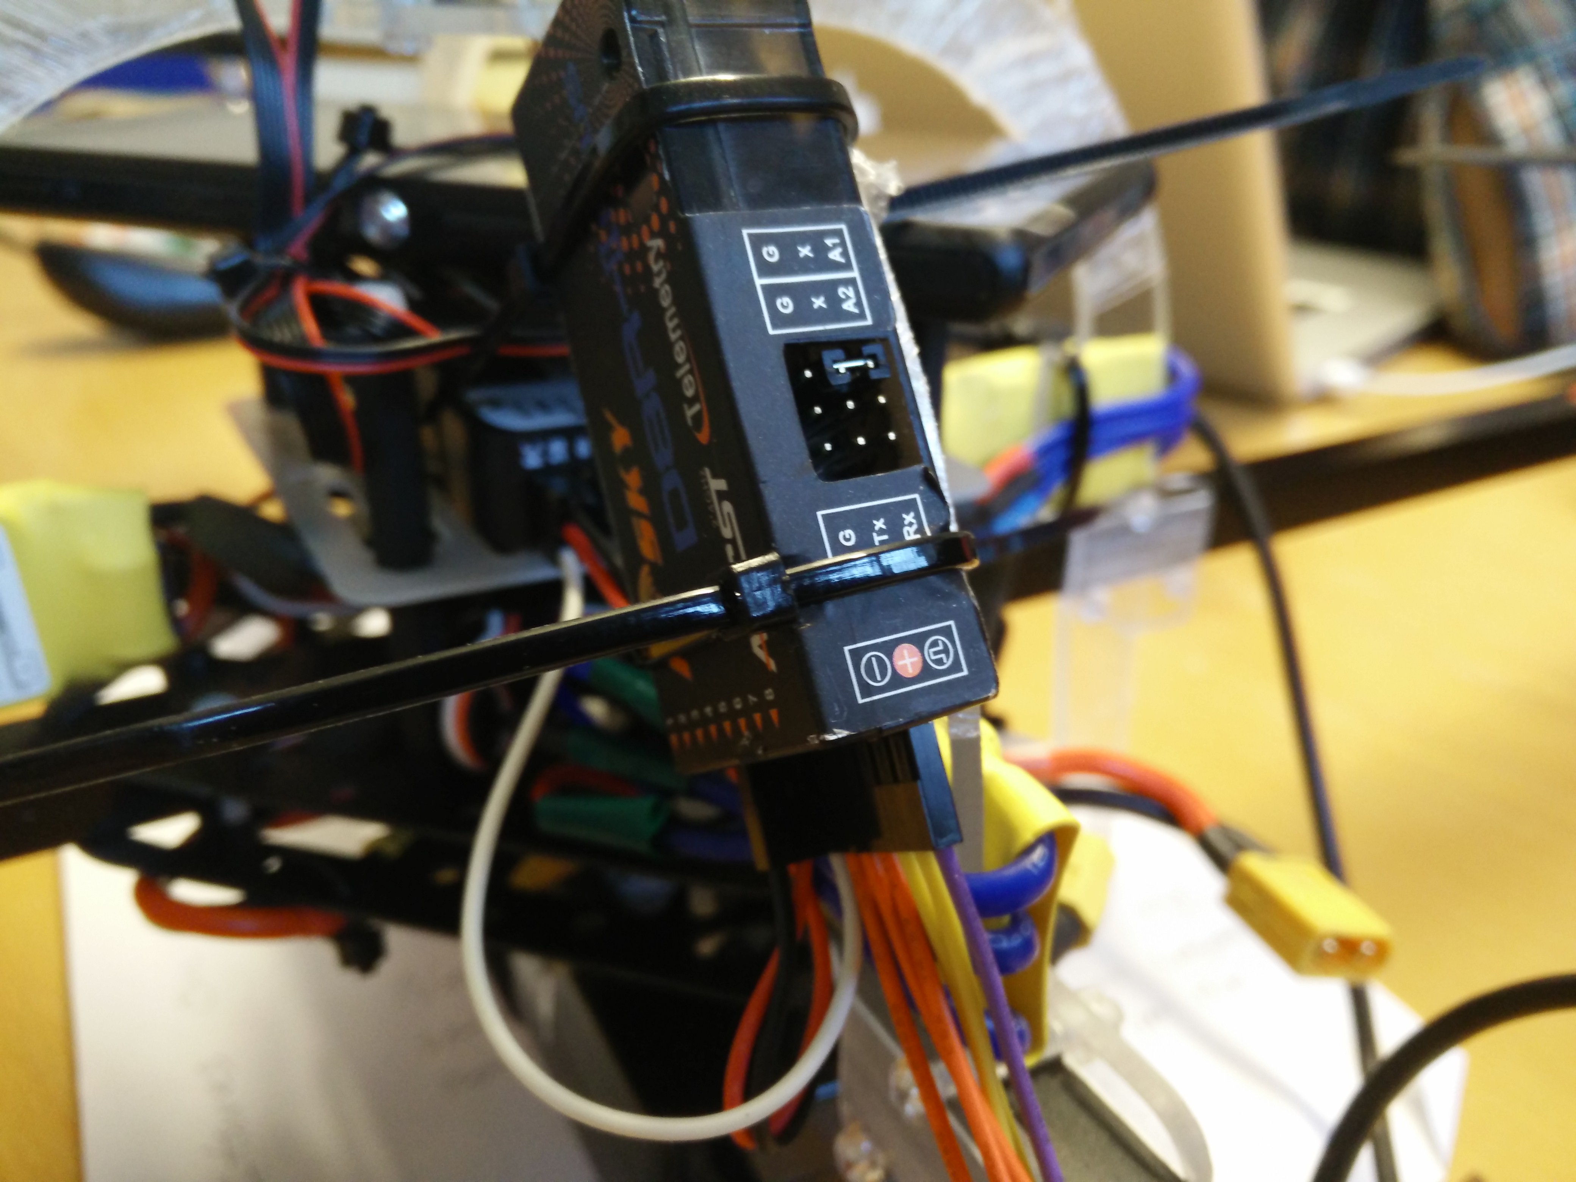

# DAQ

4GB micro-SD card that logs in a format similar to MAVlink. Use APM/Mission planner to download the data directly through the pixhawk.

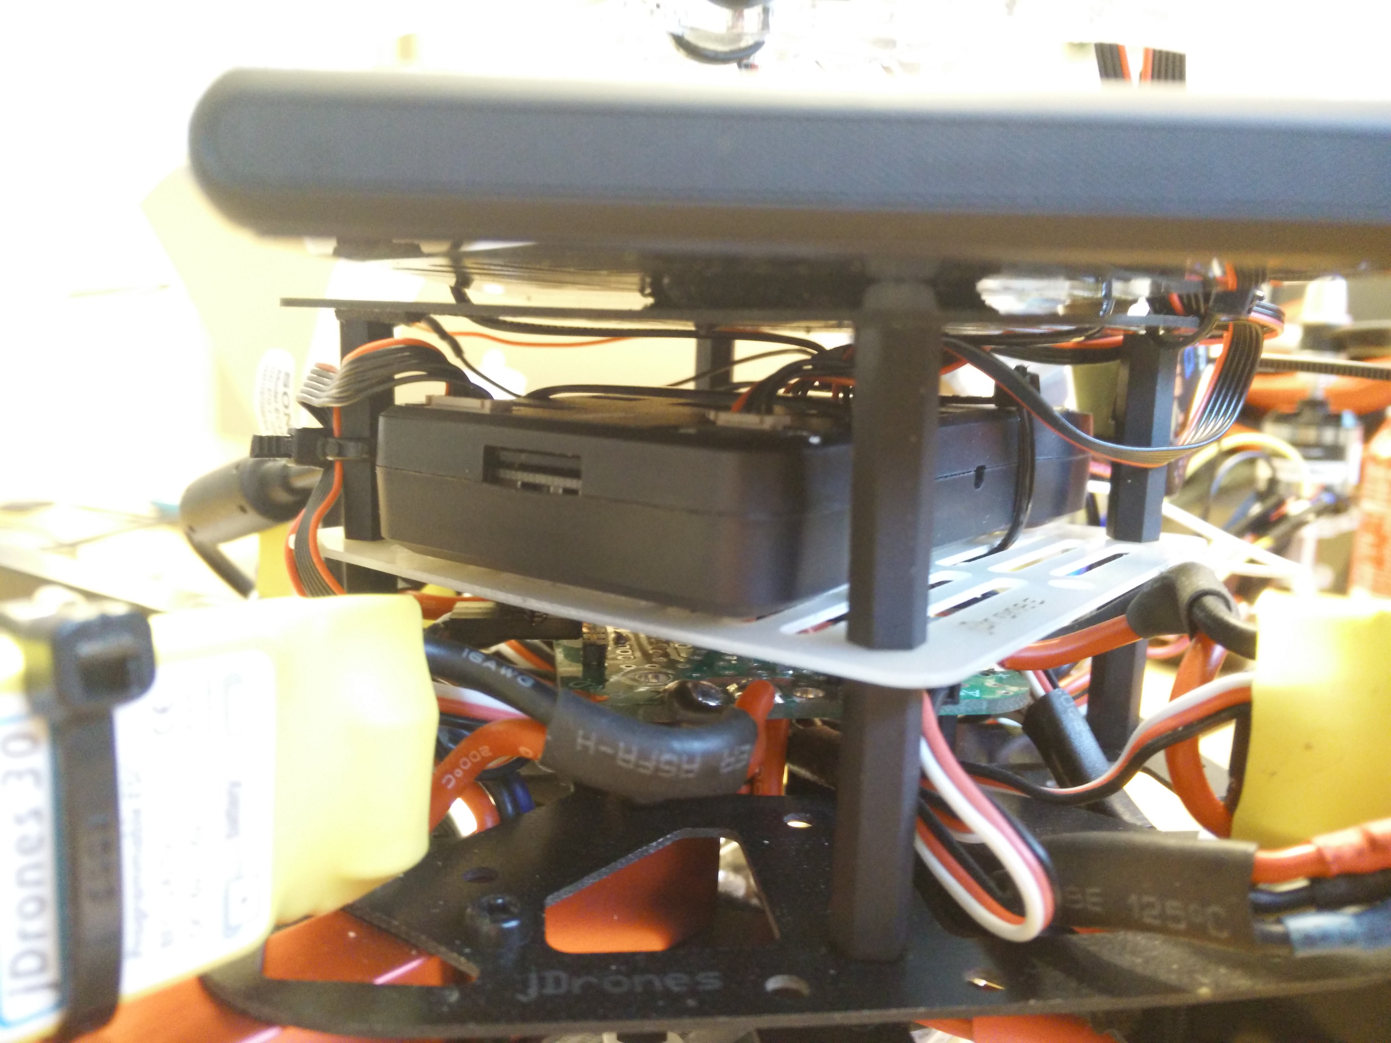

# Landing sensors

Two sensors are used for more accurate landing. The one in the red circle is Ultrasonic sensor that is used for height measurement so the drone knows when it has landed and can then turn off the motors. The sensors covered by a lens cover in the green circle are the IR-lock that is used to land accurate on a beacon.

